Pricing and Procurement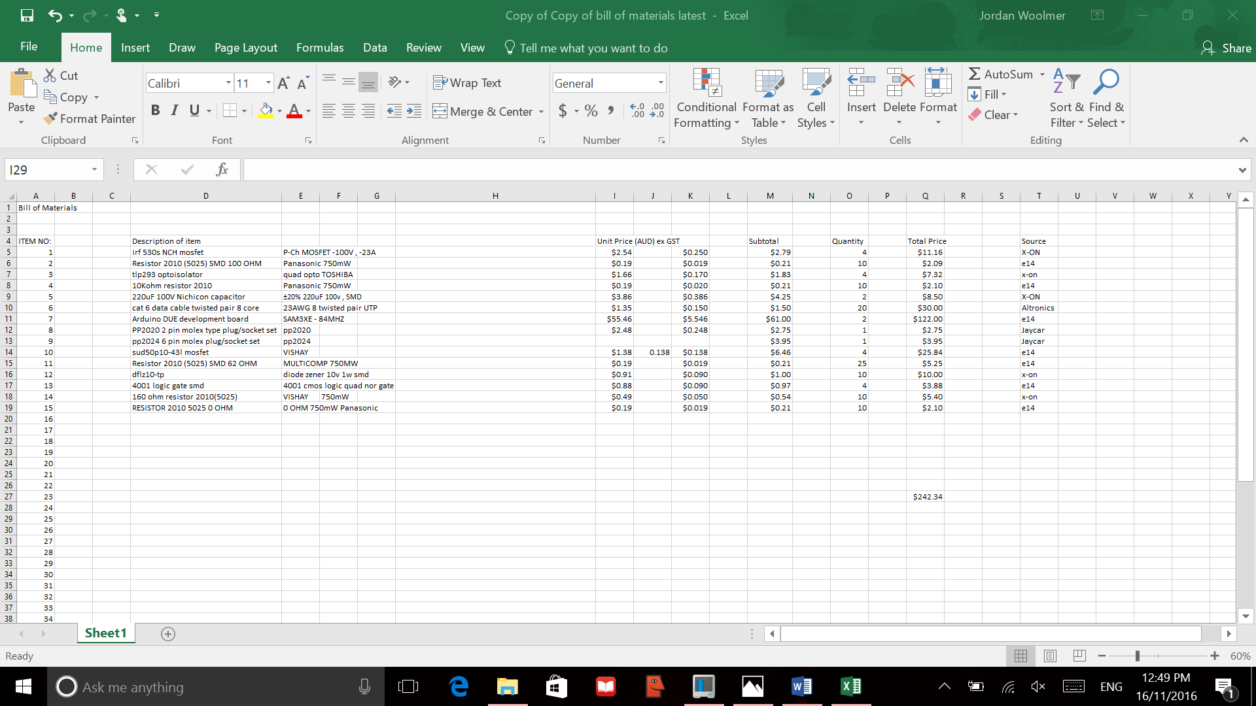

The pricing and sourcing was all through either X-ON , element14, Jaycar , and Altronics. Majority is sourced from X-ON and element14. This is because they were cheaper sources considering the fact that we could not use eBay , and they had the specific surface mount components that we required . The rest was from either Jaycar or Altronics, as they were connectors or cable that was cheaper and easier to buy locally as it was more expensive on element14/X-ON. The most expensive part was the Arduino DUE , at AUD$61 for each board. But the benefit of this is that these are the original Arduino boards , so they have the correct components with the correct bootloader , for easier programming . It is also easier to find documentation for the original , as it is more developed , and has had more revisions than other boards , as it was created first . The Arduino DUE has CANbus compatibility , which makes it ideal for our project , as well as quadrature compatibility , which is the type of encoding that the motor uses . The MOSFETS are intentionally 10 Amps at 100v , so there is plenty of overhead space for excess current and higher voltage , especially when the motor starts initially . The network protocol that we are using is RS485 , which is one of many protocols used in industry. It is a two wire system , and CAT6 cable makes for an ideal transmission medium . Inside the cable there are 4 pairs of wire , so in reality , 80 metres of twin conductor twisted pair will be available . This is more than enough , as all of the wiring will be within the pick and place machine .